STRATEGY FOR GROWTH

Rikki PArsons

**Board game lounge**

# Contents

Contents 1

Vision statement 2

View of the future 2

Current situation 3

Avenues of growth 3

Funding growth 4

Recommendation 5

Appendix 6

# Vision statement

We will be the leading brand within the Board Game Café market in the UK. We will achieve this through rapid expansion in the South of England before seeking growth further afield.

We will also explore adjacent market sectors in the entertainment hospitality space, such as ‘barcades’, Esports bars and board game bars.

All our venues must represent our core values:

* We take the hospitality aspect of our business seriously. Food and drink must be of high quality, and service must be professional.
* Our spaces must be exciting, entertaining and community hubs. Customers should always feel engaged when they visit and never bored.
* Whilst we will operate in niche markets, we must always cater for the masses. We believe that hobbies are best when shared.

# View of the future

1. The hospitality industry is changing as a result of the pandemic. The decline of traditional pubs has accelerated, and many more businesses are expected to close as covid relief schemes come to an end (furlough, VAT cuts, business rates relief).
2. The interests and habits of young people have changed. They are drinking less alcohol and seeking experiences over traditional consumption.
3. Retail led high streets are facing significant change. Department stores are closing and being replaced by blended commercial and residential units.
4. There is a geographical shift of wealth out of London. More remote working for commuters means less demand for hospitality and retail in London. House prices in commuter cities, rural and coastal areas are increasing as people are looking to get more house for their money.
5. People have more free time as work/life patterns change. Less commuting time will lead to more available time in weekday evenings.

# Current situation

Dice is a single sited hospitality business with a seasonal trading element. We operate within venue constraints that include no cellar/cold store, limited wet/dry storage space and a small food preparation area.

The business has been profitable from opening but has faced significant challenges during the pandemic. There is now a renewed focus on profitability, including effort to reduce staffing costs, review the supply chain and update pricing.

Trading levels are currently in line with 2019, but capacity is restricted by a reduction in seating. There is a healthy cash balance - including the £50k bounce back loan. This gives the potential to fund organic growth to a second site.

There remain some risks to the business – including an ongoing tribunal case and some repairs/renovations required to the Southsea site.

# Avenues of growth

Organic

* Individual single site additions over time, focusing on prime locations
* Leverage existing General Manager to open new sites and promote to backfill his post
* Recruit new teams in each new location
* Stick to the current business model but seek to expand food and drink offering – e.g. full kitchen serving one type of cuisine really well

Partnership

* Work with another organisation to expand into bigger locations or with more pace
* Leverage existing General Manager to open new sites and promote to backfill his post
* Recruit new teams in each new location
* Make some modifications to the business model to adjust to the partnership.
* Seek extra investment to fund growth

Diversification

* Individual single site addition under a separate legal entity
* Source new investment/funding. Dice Quest Limited could be a parent and own a stake.
* Recruit a full new team, utilising skills of ownership team rather than Dice Management team
* New business model in the entertainment hospitality space
* Examples include: Barcade, Wooden Games bar, RPG/escape room themed bar

# Funding growth

Retained profits

* Slower, but low risk.
* May not be able to take advantage of depressed rent values or vacant units from the recent downturn.
* Could overstretch our position and leave Dice Portsmouth with working capital issues.
* Requires no extra commitment from owners and would not dilute existing shareholding.

Debt

* There would be a cost of sourcing finance – e.g. bank loans.
* A fine balance required to not jeopardise the financial health of the existing business if a new venture was to fail.
* Limited scale for funding.
* Requires no extra commitment from owners and would not dilute existing shareholding.

Investment

* This could either involve investment into current legal entity (dilution of shares) or creation of a new legal entity with new capital injection
* Potential to gain new skills from active investors – especially desirable if branching into adjacent market sectors or new locations
* Would/could require extra funds from existing owners

Crowdfunding

* Time consuming to manage and to launch a successful campaign
* Likely to only raise a small amount of funds, unless equity is offered at a good rate
* Builds up an established customer base prior to opening that can ensure immediate traction

# Recommendation

Dice should seek to grow through organic growth, funded by retained profits. There are immediate opportunities to do so within Newbury, Basingstoke and Southampton that are worth exploring in more detail.

It is expected that these opportunities do not require extra capital on their own, but multiple could be achieved with additional funds of £50k.

Dice should also pursue a more ambitious partnership arrangement with freedomworks, focused on the Hastings site. It is expected that this would require a significant capital investment (£100-200k) to create a business that maximises the space potential. This requires further exploration as to what funding is available from the council, what it would cost to set up and how it could be funded.

# Appendix

The hospitality industry is seeing massive changes as a result of the Covid-19 pandemic. It has accelerated the decline of traditional ‘wet led’ pubs, and only around 20% of pubs and bars are highly confident that they will survive the next 3 months of trading.

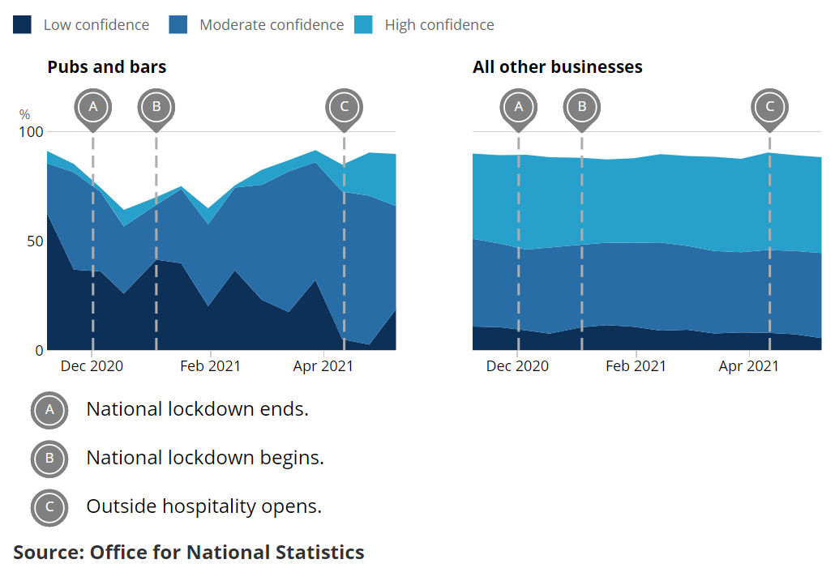

In addition to this, there is the looming threat of the furlough scheme coming to an end. This is expected to negatively impact businesses that have been exploiting the system whilst trading, or those which are facing the need to reduce headcount and may be exposed to downsizing costs.

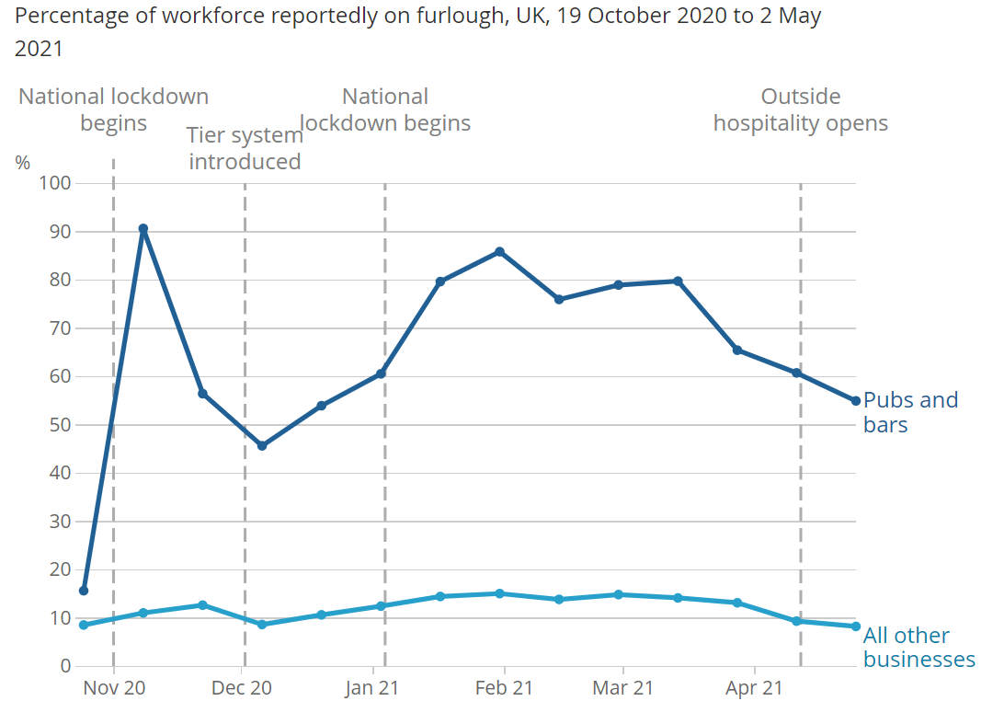

Young people drinking less. Data from the annual health survey for England and found the proportion of 16- to 24-year-olds who do not drink alcohol had increased from 18% in 2005 to 29% in 2015. Meanwhile, the proportion of “lifetime abstainers” rose from 9% to 17%. The study also appeared to show fewer young people were drinking harmful amounts.

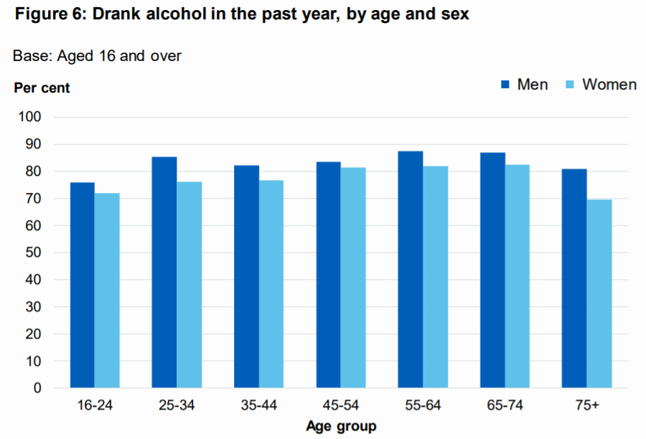

Pure hospitality experiences not enough anymore. Pubs/bars are not needed to be a hub of social interaction as people are more connected via digital platforms. People are also used to multi-tasking and distractions – struggle to keep single focus.

Retail sector want to make themed experiences – need to find way to get people to connect to the business and make

Geographical shift from London fuelled by remote working. Increased desirability of venues that are in former commuter belt town/cities.

More people with time due to reduced commutes. We are seeing an increase in weekday visitors and reduction in Friday/Saturday evening.